----------------------------------------------------------------------------------------------------------------------------------
TOURIST CONTEXT ANALYSIS

PREMISE
Objectives of the work
- Each partner will have a general overview of tourist sector situation, needs and potentials, which will be useful to support and address the start-up of new businesses;
- We will give to potential users of SUITES website (would-be enterpreuneurs) an indication about how to develop a context analysis (methodology) and where it is possibile to find relevant data and more information (sources of information, links to websites and documents).

Methodology:
- for each single point each partner develop the analysis referred to his own identified area/region
- the analysis has to be synthetic, clear, organized in paragraphs, also with the use of charts and schedule
- the analysis can be developed with a SWOT approach
- for each single point each partner indicate a list of sources of information (institutions, links to the website, documents to refer to update and deepen data and information)
- the analysis has to be produced both in English and national language
- when finished, documents can be uploaded on SUITES dropbox folder
- the analysis has to be completed before next meeting (end of March 2013)
- one innovative or sustainable new business (if identified) can be invited to participate in next meeting

FORM OF ANALYSIS

 | Area of analysis | Description/precise identification of the area involved in the analysis
Brief description and charts(if needed)

Sources of information/relevant links

A | Data about Tourist demand |  |  |  |  | More recent data available (at least 2011). This part can be developed synthetically with a short description and charts
1 | Current tourist demand's picture
1.1 | tourist presence |  |  |  |  | Number of nights of permanence
 | Number of presence (general data 2011) |  |  |  |  | 13 214 304 (2011)
 | Number of presence referred to national tourists (percentage from specific national regions/areas) |  |  |  |  | 1 273 133 (9,6%)
 | Number of presence referred to tourists from foreign countries (percentage from foreign countries of origin) |  |  |  |  | 11 941 171 (90,4%)
Brief description and charts(if needed)
As we can see much more tourists presence are from foreign countries (90, 6%) than from Czech republic. The number of tourist presence is still growing.

Sources of information/relevant links
http://cestovniruch.praha.eu/jnp/cz/pruzkumy_a_statistiky/rok_2011/index.html
http://www.czso.cz/xa/redakce.nsf/i/navstevnost_hromadnych_ubytovacich_zarizeni_v_hl_m_praze_v_roce_2011

1.2 | tourist arrivals |  |  |  |  | Number of customers arrived (only 1st night)
 | Number of arrivals (general data 2011) |  |  |  |  | 5 132 040 (2011)
 | Number of arrivals referred to national tourists (percentage from specific national regions/areas) |  |  |  |  | 698 992 (13,6%)
 | Number of arrivals referred to tourists from foreign countries (percentage from foreign countries of origin) |  |  |  |  | 4 433 048 (86,4%)
Brief description and charts(if needed)
As we can see, much more tourists arrivals are from foreign countries (86,4%) than from Czech republic. The number of tourist arrivals is still growing; in the last few years it was more than 5 million.

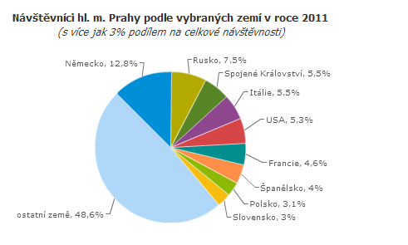
Visitors in Prague by selected countries in 2011 – most visitors are from Germany (12,8%), Russia (7,5%), United Kingdom and Italy.

Sources of information/relevant links
http://cestovniruch.praha.eu/jnp/cz/pruzkumy_a_statistiky/rok_2011/index.html

1.3 | average permanence rate |  |  | presence/arrivals (for ex. 2.000.000/1,200.000)
 | general data 2011 |  |  | 2, 575
 | percentage from specific national regions/areas |  |  | 1,82
 | percentage from foreign countries of origin |  |  | 2,69
Sources of information/relevant links
http://vdb.czso.cz/vdbvo/maklist.jsp?q_rezim=1&kapitola_id=39&vo=null&q_text=&expand=0
http://www.czso.cz/x/krajedata.nsf/oblast2/cestovni_ruch-xa
http://www.czso.cz/csu/redakce.nsf/i/cru_cr
http://www.czso.cz/x/krajedata.nsf/krajemetodika/xa#pocet_hostu

1.4 | average per head expenses
 | general data 2011 |  |  |  | 80 euros (2 000 Kč) – general Czech republic
 | data referred to national tourists |  |  |  | 40 euros (1 000 Kč)
 | data referred to tourists from foreign countries |  |  |  | 120 euros (2 962 Kč)
Brief description and charts(if needed)
As we can see the tourist from foreign countries are spending more money than national tourists.
Sources of information/relevant links
Source: STEM/MARK, Strukturalizace výsledků šetření Příjezdový cestovní ruch 2009-2015 do jednotlivých krajů

2 | Tourist trends
2.1 | tourist presence
 | trend in last 5 years (general data) | 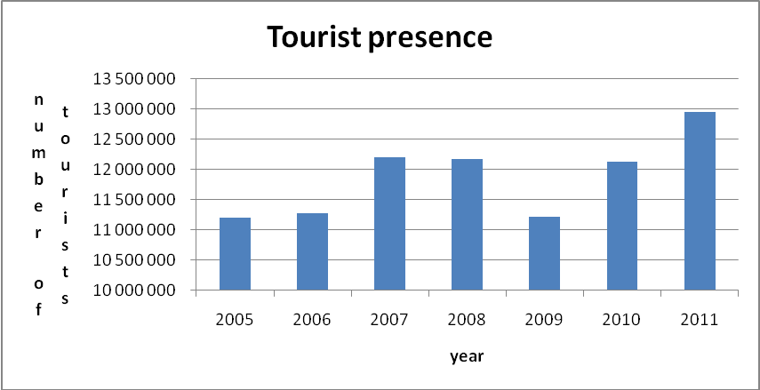
 | trend in last 5 years referred to national tourists | 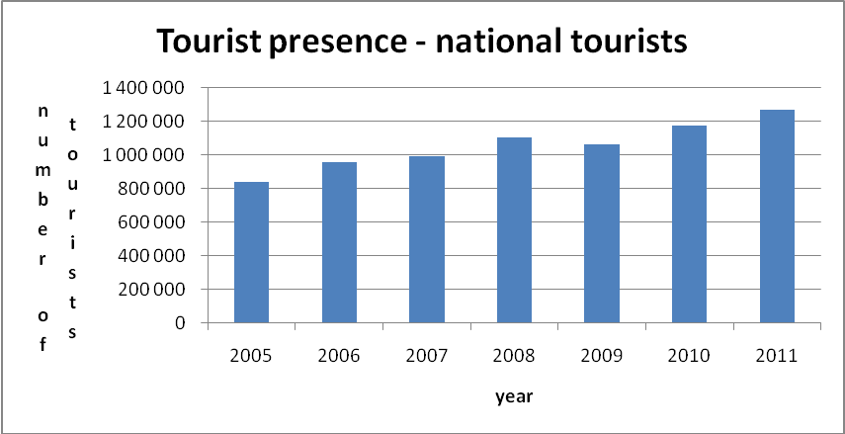
 | trend in last 5 years referred to tourists from foreign countries | 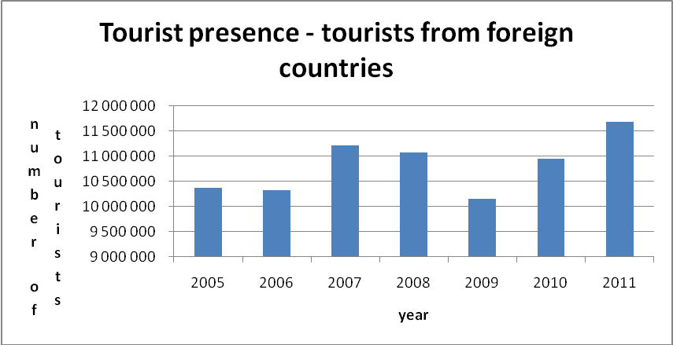
Brief description and charts(if needed)
As we can see, the number of tourists is growing almost every year. In 2009, the number of tourists was smaller due to financial crisis. In the last years, the number of national tourist has been growing. The biggest numbers of foreign tourists come from Germany, Italy and Russia. The current trend is that tourists stay in Czech Republic for shorter period. Most of the tourists stay at Prague only for one or two days.

Sources of information/relevant links
http://vdb.czso.cz/vdbvo/maklist.jsp?q_rezim=1&kapitola_id=39&vo=null&q_text=&expand=0
http://www.czso.cz/x/krajedata.nsf/oblast2/cestovni_ruch-xa
http://www.czso.cz/csu/redakce.nsf/i/cru_cr
http://www.czso.cz/x/krajedata.nsf/krajemetodika/xa#pocet_hostu

2.2 | tourist arrivals
 | trend in last 5 years  (general data) | 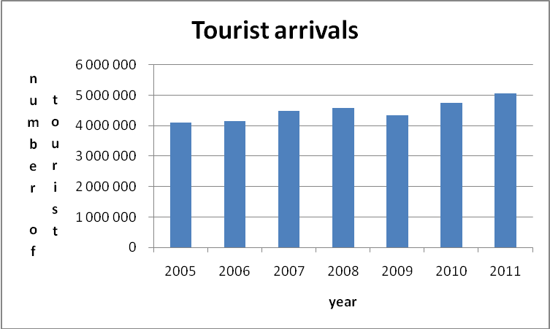
 | trend in last 5 years referred to national tourists | 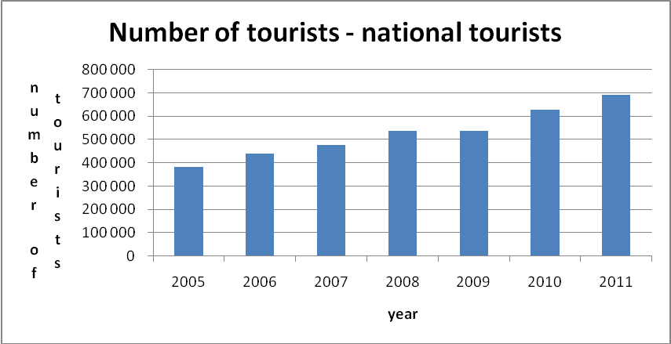
 | trend in last 5 years referred to tourists from foreign countries | 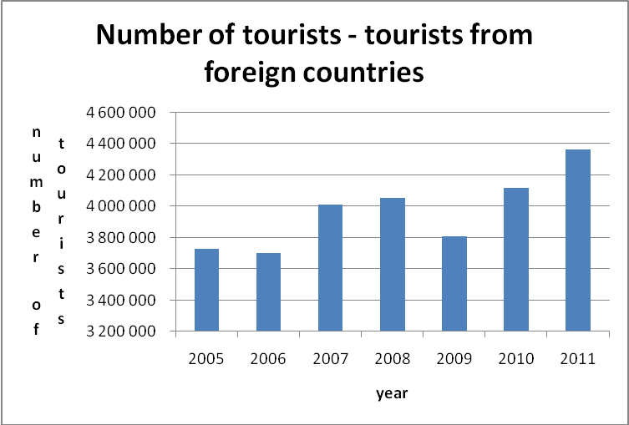
Brief description and charts(if needed)
As we can see, the number of tourists during last years is pretty much similar. In the last years, the number of national tourist has been growing because of the financial crisis – Czech people don’t have money for traveling abroad. Most of the foreign tourists come from Germany, Italy and United Kingdom. The current trend is to stay rather short period at Czech Republic.

Sources of information/relevant links
http://vdb.czso.cz/vdbvo/maklist.jsp?q_rezim=1&kapitola_id=39&vo=null&q_text=&expand=0
http://www.czso.cz/x/krajedata.nsf/oblast2/cestovni_ruch-xa
http://www.czso.cz/csu/redakce.nsf/i/cru_cr
http://www.czso.cz/x/krajedata.nsf/krajemetodika/xa#pocet_hostu

2.3 | average permanence rate
 | trend in last 5 years (general data) |  | 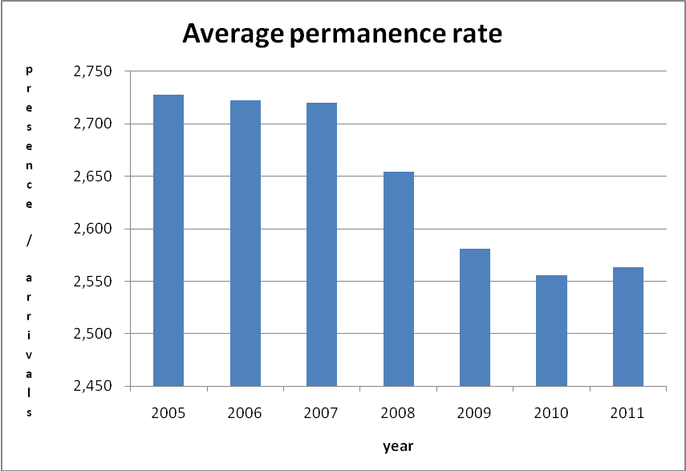
 | trend in last 5 years referred to national tourists |  | 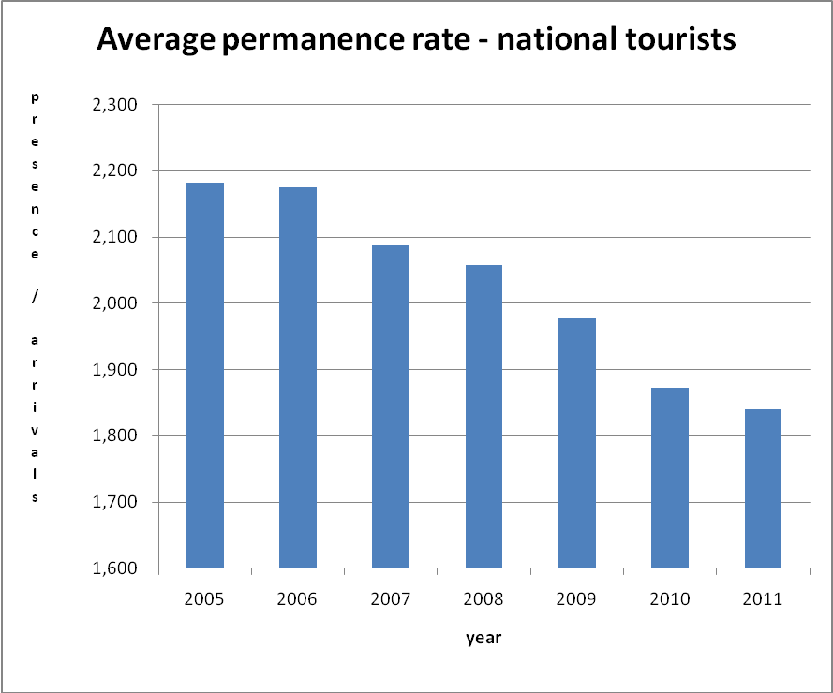
 | trend in last 5 years referred to tourists from foreign countries |  | 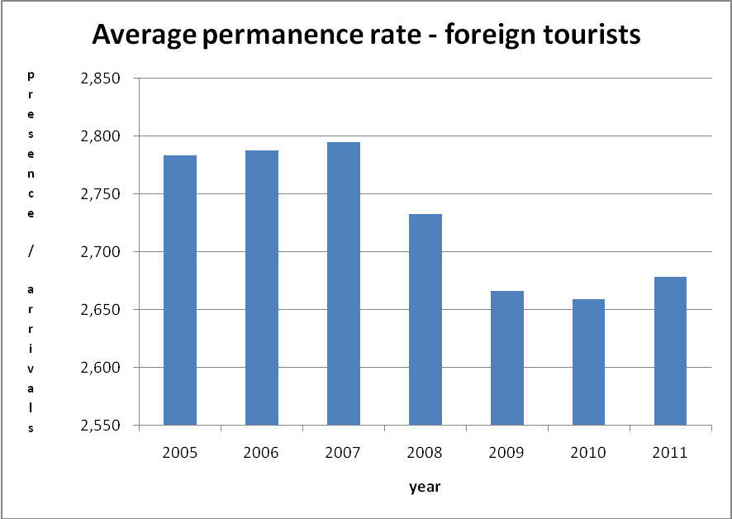
Brief description and charts (if needed)
In the last few years, the average permanence rate is decreasing. It also applies for national tourist and tourist from foreign countries.
Sources of information/relevant links
http://vdb.czso.cz/vdbvo/maklist.jsp?q_rezim=1&kapitola_id=39&vo=null&q_text=&expand=0
http://www.czso.cz/x/krajedata.nsf/oblast2/cestovni_ruch-xa
http://www.czso.cz/csu/redakce.nsf/i/cru_cr
http://www.czso.cz/x/krajedata.nsf/krajemetodika/xa#pocet_hostu

2.4 | tourist profile
 | average age (age segments and %) |  |  |  |  |  | 15-29 y.o. – 38%  30-44 y.o. – 37%  45-59 y.o. – 19%  60 and more – 7%
 | level of education (general description and informations) |  |  |  |  |  | High school and University
 | typology of employment (general description and information) |  |  |  |  |  | Unknown
 | how he moves (means of transport) |  |  |  |  |  | Tram, metro, bus
 | with whom he moves (family, groups, in couple) - (general description and information) |  |  |  |  |  | Most of the tourists travel in groups, family is the next popular option
 | ways used for organizing the travel (by himself, online tools, tour operators...) - (general description and information) |  |  |  |  |  | Especially online, tour operators  Some of them by himself like individual tourist with booking something
 | main motivation of the travel (for work, relax, cultural attractions…) |  |  |  |  |  | Relax, holiday, touristic, sports, heritage, cultural attractions and sport action (Moto GP …), history, architecture, shopping,
Brief description and charts(if needed)
The number of tourist between the age of 15-29 and 30-44 travelling to Czech Republic, is almost equal. Most of the tourists are either high school or university students. When the tourists are in Prague, they are using mainly tram and underground, but also buses. The aim of visiting Czech republic is relaxation, holiday, cultural and historical heritage etc

B | Tourist Offer
3 | Accommodation facilities (trend)
3.1 | accommodation structures
 | trend of the number of accommodation structures in last 5 years | 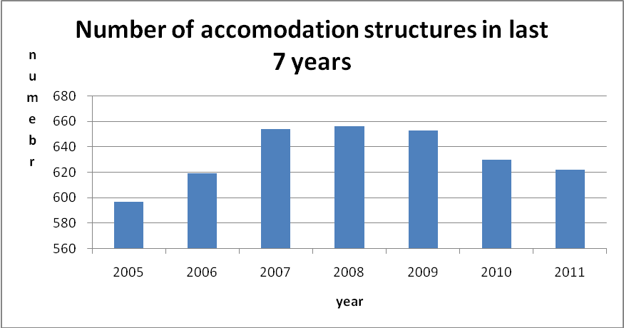
 | trend of the number of accommodation structures in last 5 years - referred to hotels | 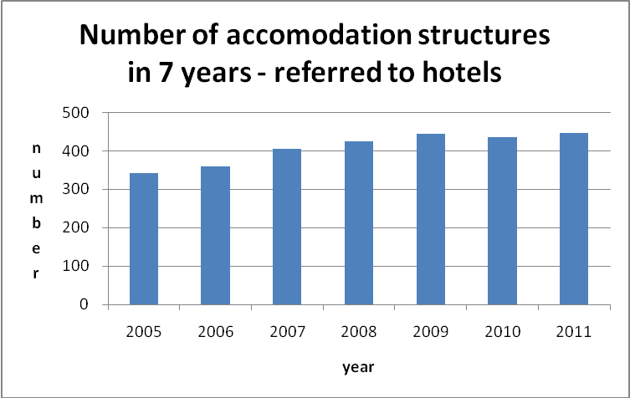
 | trend of the number of accommodation structures in last 5 years - referred to other typologies of accommodation | 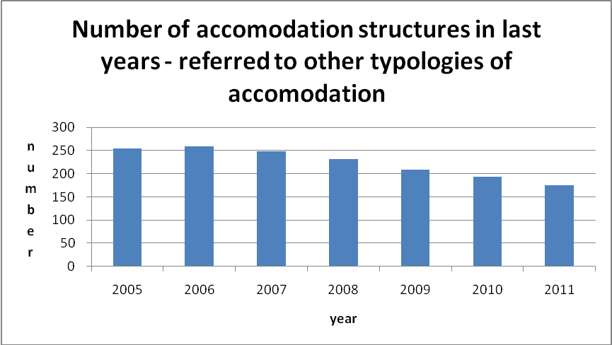
Brief description and charts(if needed)
As we can see, the biggest number of accommodation structures was in the years 2007-2009. It was almost 660. The smallest number was in the 2005. The number of accommodation structures in the hotels is still growing. We can see that it is more than 400. On the other side, the number of accommodation structures in other typologies is decreasing.

Sources of information/relevant links
http://www.czso.cz/x/krajedata.nsf/oblast2/cestovni_ruch-xa

3.2 | sleeping accomodation
 | trend of the number of sleeping accomodation in last 5 years | 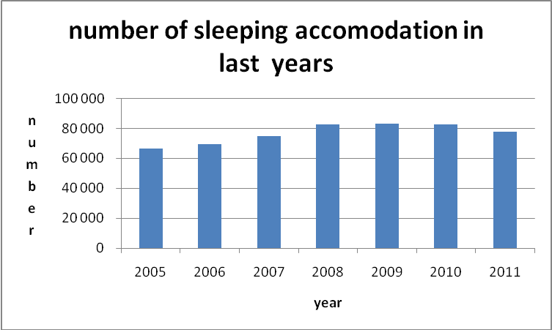
 | trend of the number of sleeping accomodation in last 5 years - referred to hotels | Data are missing
 | trend of the number of sleeping accomodation in last 5 years - referred to other typologies of accomodation | Data are missing
Brief description and charts (if needed)
In the few last years the number of accommodation is almost the same. It is between 60 000 (2005) and 80 000 (2008 – 2009)

Sources of information/relevant links
http://www.czso.cz/x/krajedata.nsf/oblast2/cestovni_ruch-xa

4 | Accommodation facilities - Current picture
4.1 | accomodation structures
 | number of accomodation structures in 2011 | 622
 | number of hotels in 2011 | 447
 | number of accomodation other typologies of structures | 175
Brief description and charts(if needed)
The Czech republic has more accommodation structures in hotels. Its almost 75% from all.

Sources of information/relevant links
http://www.czso.cz/csu/redakce.nsf/i/cru_cr

4.2 | sleeping accomodation
 | number of sleeping accomodation in 2011 | 77 972 (number of beds)
 | number of hotels accomodation in 2011 | 31 937, 36 969 (number of rooms)
 | number of sleeping accomodation in other typologies of structures | 5 032
Brief description and charts(if needed)
In the all Czech republic we can find almost 80 thousand beds for sleeping. The biggest number of beds is in hotels.

Sources of information/relevant links
http://www.czso.cz/csu/redakce.nsf/i/cru_cr

5 | Services and infrastructures
5.1 | Description (and data) of the presence of transport infrastructures, tourist information points, trekking and cycling paths, restaurants, means of transport, networks (like tourist cards)… | http://www.prazskecyklostezky.cz/default.aspx - this link is for cycling routes  http://www.turistika.cz/praha/trasy - this link is for walking routes  http://www.dpp.cz/ - transport infrastructure  http://cz.marys.cz/sightseeing/prague-card/, http://www.praguewelcome.cz/cs/pamatky/turisticke-sluzby/turisticke-karty/ - tourist cards
Brief description and charts(if needed)
Points of services and infrastructures:
http://www.praguewelcome.cz/cs/pamatky/turisticke-sluzby/turisticke-karty/

5.2 | Links to sites for tourist promotion (where tourists can find offer) - ex. Tour operators, touristic web site, ecc.) | www.czechtoursim.com, www.czechtourism.cz, http://www.accka.cz/, http://www.praha.eu/jnp/cz/home/magistrat/odbory_mhmp/?divisionId=168, http://www.myczechrepublic.com/, http://www.praguewelcome.cz/en/, http://czechunderscope.com/, http://www.czech.cz/en/Tourism
5.3 | Cooperation (presence of clusters, networks, public- private cooperations) in tourism sector and their responsability (and links to web site) | Czech tourism (www.czechtourism.com, www.czechtourism.cz,)
 | Attractions, facilities, key tourist issues | Heritage, fun, culture, beer, food
Brief description and charts(if needed)
The most famous attractions in Prague are cultural heritage, specially the Old town of Prague (belongs to UNESCO world heritage sites).
Prague has a lot of opportunities for young people: lots of spots for parties, famous Czech beer and food.
Sources of information/relevant links
www.praguewelcome.cz/

5.5 | Other services | Police ( call 158), Rescue (155), Fire brigade (150), City police Prague (156)
Brief description and charts(if needed)
Police: 158, Ambulance: 155 Fire services 150.

Sources of information/relevant links
http://www.mppraha.cz/informace/dulezita-telefonni-cisla.htm

C | Tourism Local Policies and strategies
6 | Institutional referents for tourist sector
6.1 | Local referents for tourist policies | Prague municipality responsible for tourism in Prague, contacts can be found on this link: http://www.praha.eu/jnp/cz/home/magistrat/odbory_mhmp/index.html?departmentId=651  Another institution is Ministry for regional development –  http://www.mmr.cz/cs/Podpora-regionu-a-cestovni-ruch/Cestovni-ruch
6.2 | Tourism development strategies for next years | Prague as an important development of the newly formed Europe - to promote "market European cities."  Preserve the character of the individual parts of the city without violation of the genius loci of Prague and Prague in particular conservation areas.  Strengthening image of Prague as a cultural and historical phenomenon and internationally.  Prague – Prague “like an attractive address”  National programme of support for tourism year 2013  The concept of national tourism policy in the Czech Republic for the period 2007-2013
Brief description and charts(if needed)
As we can see Prague is really active city in some development projects. We can find a lot of project for tourism.

Sources of information/relevant links
www.czechtourism.cz/files/regiony/rozvoj/cestovni_ruch.pdf

7 | Tourist laws/regulations
7.1 | Main laws/regulation in tourist sector |  | The list of law  http://www.cestovni-ruch.cz/zakony/index.php,  http://www.mmr.cz/cs/Ministerstvo/Ministerstvo/Pro-media/Medialni-reakce/Komentar-MMR-k-zakonu-o-podnikani-v-cestovnim-ruch,
Brief description and charts(if needed)
The foreign tourists can find some information about law in the attached links.

7.2 | Law/ administrative requirements for Tourists |  | Up to 3 months visa free stay
Brief description and charts(if needed)
Non-EU tourists don’t need a visa of or special travel permission if their stay doesn’t exceed 3 month.
All relevant information can be found:
http://www.mvcr.cz/clanek/prijezd-do-cr-povinnosti-a-delka-pobytu.aspx
The tourist from EU don´t need special permission or visa.

7.3 | Main local financial opportunities for tourist sector |  | The national programe of support for tourism (2010 – 2013)  This link is for applaying grants in Prague - http://cestovniruch.praha.eu/jnp/cz/granty_hl_m_prahy/index.html
Brief description and charts(if needed)
We can find in Czech republic some opportunities for taking a special grant for tourism. The Czech republic has some project for developing tourism.

Sources of information/relevant links

8 | Other
8.1 | Country reputation |  | In this table we can see position of Czech republic in the country brand index in individual categories as Bloom consulting Trade and Tourism. Czech republic is in the better half of the all countries. In the future we can see that position is same.
Brief description and charts(if needed)
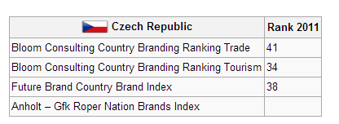

Sources of information/relevant links
http://countrybrandingwiki.org/index.php/Rankings_-_Country_by_Country#C
http://nation-branding.info/

8.2 | Foreseen projects related to tourist sector (opening of a new museum, building of new infrastructures…) |  | In Prague is planning to open new line of underground, which is better for infrastructure and tourists will have more opportunities for visiting famous places.  Another plan is opening new museum of young art.
Sources of information/relevant links
http://www.praguecityline.cz/prazske-pamatky/muzeum-moderniho-umeni-museum-of-young-art
http://www.novemetro.cz/

8.3 | Tripadvisor opinions about the area |  | http://www.tripadvisor.com/Tourism-g274707-Prague_Bohemia-Vacations.html,  http://www.tripadvisor.com/Hotels-g274707-Prague_Bohemia-Hotels.html,
Brief description and charts (if needed)
Tripadvisor can be very useful for tourists visiting Czech Republic

D | Innovation
9.1 | Internet and wi-fi coverage (data and/or general description) | 62% of household is connecting to wi-fi  Coverage on all Czech republic is really good
Brief description and charts(if needed)
In the Czech Republic, almost 75% of people have internet connection, out of that, more than 60% of people have wi-fi connection at home. The internet connection coverage is very good, one can finds lots of companies providing internet, in addition to that, there are three main mobile operators.

Sources of information/relevant links
http://www.czso.cz/csu/redakce.nsf/i/informacni_technologie_ve_spolecnosti
http://www.webdesign.paysoft.cz/clanky/2006/historie-ceskeho-internetu/
http://cs.wikipedia.org/wiki/Internet

9.2 | Cool hunting (identification of new trends in Tourist sector) | Visiting special place – disco, clubs  Dark tourism – visiting place after flood
Brief description and charts(if needed)
Tourists can find a lot of bars, pubs and clubs in Prague. For sport activities, Prague has a lot of opportunities – both indoor facilities and outdoor facilities such as plenty of parks or tennis fields for instance. The new raising trend is extreme tourism – tourists are interested in natural disasters such as floods or extreme heat.
9.3 | Identification of Best Practices of innovative services and companies with the application of new web 2.0 technologies to tourist sector | http://pragulic.cz/
Brief description and charts(if needed)
Pragulic is a innovative start-up in tourism field where the homeless guides will guide the tourists Prague’s undiscovered places, showing them around places that are only known for the locals.

9.4 | National opinion leaders | hlavacek@czechtourism.cz
Brief description and charts(if needed)
Czech-tourism institute.
Sources of information/relevant links
http://www.czechtourism.cz/institut-turismu/kontakty-5/

E | Sustainability
10.1 | Best practices (hotels, crafts, products) of sustainable services and practises in tourist sector (Enviromental-Friendly Businesses) | http://www.mmr.cz/getmedia/cc80193b-e4e8-4694-8a65-728df70a5fd8/GetFile14_2.pdf
Brief description and charts(if needed)
Website about means of sustainable tourism.

10.2 | Local policies about sustainability | Ministry of Enviroment -http://www.mzp.cz/cz/udrzitelny_rozvoj
10.3 | Enviromental-Friendly Mobility examples
Brief description and charts(if needed)

Sources of information/relevant links

10.4 | National opinion leaders | Link to forum, blog, people, companies who can be considered as opinion leaders about this issue
Brief description and charts(if needed)

Sources of information/relevant links

F | Best practise in tourist sector | Each partner tries to identify an example of innovative or sustainable new business in tourist sector in his area, to be involved in second meeting as a best practise.  Identification of best practises is not obligatory, if partners don't have or can’t find them on their territory

