TOURIST CONTEXT ANALYSIS OF ÇEŞME

Çeşme Kaymakamlığı - Çeşme Esnaf Odası - ÇEŞTOB

Objectives of the work
Each partner will have a general overview of tourist sector situation, needs and potentials, which will be useful to support and address the start-up of new businesses;
We will give to potential users of SUITES website (would-be enterpreuneurs) an indication about how to develop a context analysis (methodology) and where it is possibile to find relevant data and more information (sources of information, links to websites and documents).

Methodology:
for each single point each partner develop the analysis referred to his own identified area/region
the analysis has to be synthetic, clear, organized in paragraphs, also with the use of charts and schedule
the analysis can be developed with a SWOT approach
for each single point each partner indicate a list of sources of information (institutions, links to the website, documents to refer to update and deepen data and information)
the analysis has to be produced both in English and national language
when finished, documents can be uploaded on SUITES dropbox folder
- the analysis has to be completed before next meeting (end of March 2013)
one innovative or sustainable new business (if identified) can be invited to participate in next meeting

FORM OF ANALYSIS

 |  | Area of analysis |  | ÇEŞME-ALAÇATI  Çeşme is a coastal town and the administrative centre of the district, it is also the name of the peninsula where the town is located. It is a popular holiday resort and the district center, where two thirds of the district population is concentrated. Çeşme is located 85 km. west of İzmir, the largest metropolitan center in Turkey's Aegean Region. There is a six-lane highway connecting the two cities (Otoyol 32). Çeşme district has two neighboringdistricts, Karaburun to the north and Urla to the east, both of which are also part of İzmir Province. The name "Çeşme" means "fountain" referent with Ottoman fountains across the city.  A prized location of country houses and secondary residences especially for the well-to-do inhabitants of İzmir since more than a century, Çeşme perked up considerably in recent decades to become one of Turkey's most prominent centers of international tourism. Many hotels, marinas, clubs, restaurants, boutique hotels, family accommodation possibilities (pensyon) and other facilities for visitors are found in Çeşme center and in its surrounding towns and villages and the countryside, as well as very popular beaches.  Çeşme district has one depending township with own municipal administration, Alaçatı, where tourism is an equally important driving force as the district center area and which offers its own arguments for attracting visitors, as well as four villages: Ildırı on the coast towards the north, which is notable for being the location of ancient Erythrae, and three others which are more in the background, in terms both of their geographical location and renown: Germiyan, Karaköy and Ovacık, where agriculture and livestock breeding still forms the backbone of the economy.  In relation to tourism, it is common for the resorts along Çeşme district's 90 km coastline to be called by the name of their beaches or coves or the visitor's facilities and attractions they offer, as in Şifne (Ilıca), famous both for its thermal baths and beach, and in Çiftlikköy (Çatalazmak), Dalyanköy, Reisdere, Küçükliman, Paşalimanı, Ayayorgi, Kocakarı, Kum, Mavi and Pırlanta beaches; Altunyunus, synonymous with a large hotel located in its cove; and Tursite, by the name of the villas located there.  The town of Çeşme lies across a strait facing the Greek island of Chios, which is at a few miles' distance and there are regular ferry connections between the two centers, as well as larger ferries from and to Italy (Brindisi, Ancona and Bari) used extensively by Turks of Germany returning for their summer holidays.
Brief description and charts(if needed)

Sources of information/relevant links

 | A |  | Data about Tourist demand |  |  | More recent data available (at least 2012). This part can be developed synthetically with a short description and charts
 | 1 |  | Current tourist demand's picture
 | 1.1 |  | tourist presence |  |  | number of nights of permanence
 |  |  | Number of presence (general data 2011)
 |  |  | Number of presence referred to national tourists (percentage from specific national regions/areas) |  |  | Total number of national tourists is: 1.481.619. It is % 87 of the whole.
 |  |  | Number of presence referred to tourists from foreign countries (percentage from foreign countries of origin) |  |  | Total Number of foreigner tourist is :219.732. It is % 13 of the whole.
87 % of the total current tourist demand is from different regions of the country. That means Çeşme is a popular tourism destination for Turkish tourists. Only thirteen percent of whole tourist presence is foreigners.
Sources, related links:
Çeşme tourism information office,
Çeşme Turistik Otelciler Birliği
http://www.cestob.com/

 | 1.2 |  | tourist arrivals |  | number of customers arrived (only 1st night)
 |  |  | Number of arrivals (general data 2011) |  | 636.985
 |  |  | tourists (percentage from specific national regions/areas) |  | 578.250 –
 |  |  | Number of arrivals referred to tourists from foreign countries (percentage from foreign countries of origin) |  | 58.735 -
charts(if needed)
Sources, related links:
Çeşme tourism information office,
Çeşme Turistik Otelciler Birliği
http://www.cestob.com/

 | 1.3 |  | average permanence rate | presence/arrivals (for ex. 2.000.000/1,200.000)
 |  |  | general data 2011 | 1.701.351:636.985 = 2.70
 |  |  | percentage from specific national regions/areas | 1.481.619:578.250 = 2.56
 |  |  | percentage from foreign countries of origin | 219.732:58.735 = 3.75
Brief description,
Sources, related links:
Çeşme tourism information office,
Çeşme Turistik Otelciler Birliği
http://www.cestob.com/

 | 1.4 |  | average per head expenses
 |  |  | general data 2011 | 319 euros
 |  |  | data referred to national tourists | 150 euros
 |  |  | data referred to tourists from foreign countries | 469 euros
 | 2 |  | Tourist trends
 | 2.1 |  | tourist presence
 |  |  | trend in last 5 years (general data) | 2012: 1.701.351  2011: 2.315.017  2010: 1.798.744  2009: 1.364.607  2008: 1.286.761
 |  |  | trend in last 5 years referred to national tourists | 2012: 1.481.619  2011: 1.730.278  2010: 1.437.806  2009: 1.048.472  2008: 1.009.780
 |  |  | trend in last 5 years referred to tourists from foreign countries | 2012: 219.732  2011: 584.739  2010: 360.938  2009: 316.135  2008: 276.981
Charts if needed

Related links
 | 2.2 |  | tourist arrivals
 |  |  | (general data)  trend in last 5 years (general data) |  | 2012: 636.985  2011: 758.903  2010: 643.720  2009: 482.576  2008: 432.413
 |  |  | trend in last 5 years referred to national tourists |  | 2012: 578.250  2011: 635.848  2010: 582.830  2009: 415.361  2008: 383.575  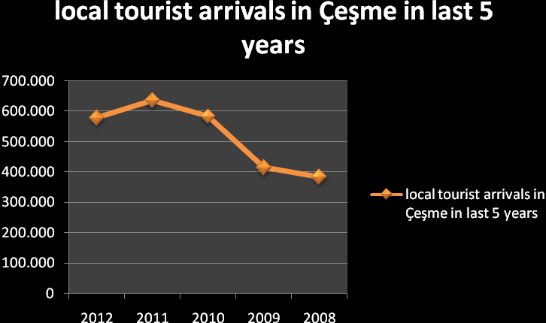
 |  |  | trend in last 5 years referred to tourists from foreign countries |  | 2012: 58.735  2011: 123.055  2010: 60.890  2009: 67.215  2008: 48.838  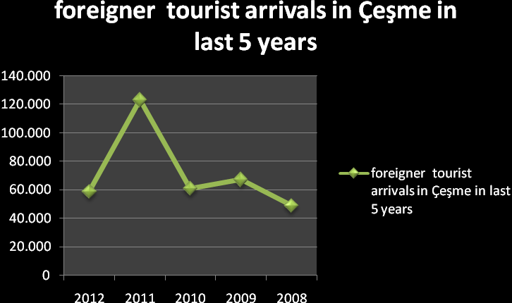
Charts if needed
Related links

 | 2.3 |  | average permanence rate
 |  |  | (general data)  trend in last 5 years (general data) | Years-days  2012: 2.67  2011: 3.63  2010: 2.79  2009: 2.82  2008: 2.97
 |  |  | trend in last 5 years referred to national tourists | 2012: 2.56  2011: 2.72  2010: 2.46  2009: 2.52  2008: 2.63  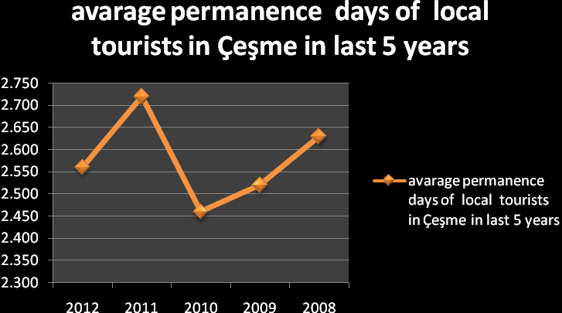
 |  |  | trend in last 5 years referred to tourists from foreign countries | 2012: 3.74  2011: 4.75  2010: 5.92  2009: 4.70  2008: 5.67  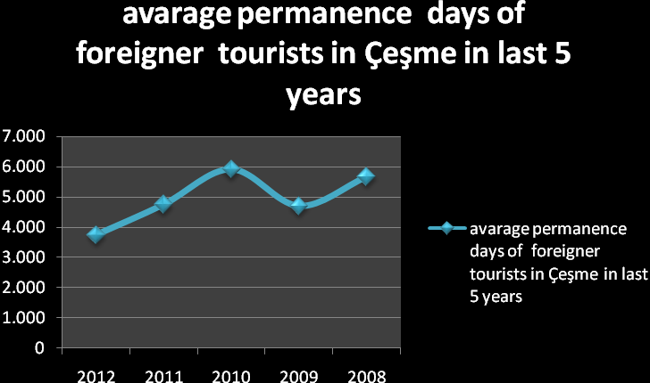
Brief description,
Sources, related links:
Çeşme tourism information office,
Çeşme Turistik Otelciler Birliği
http://www.cestob.com/

 | 2.4 |  | tourist profile
 |  |  | average age (age segments and %) | 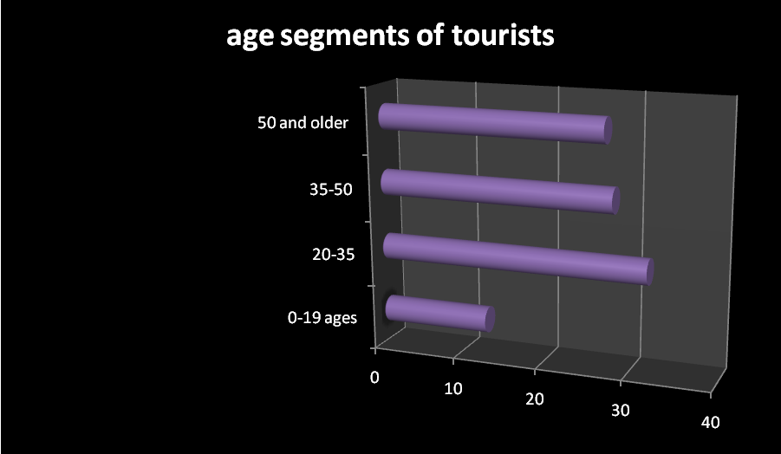
 |  |  | level of education (general description and informations) | 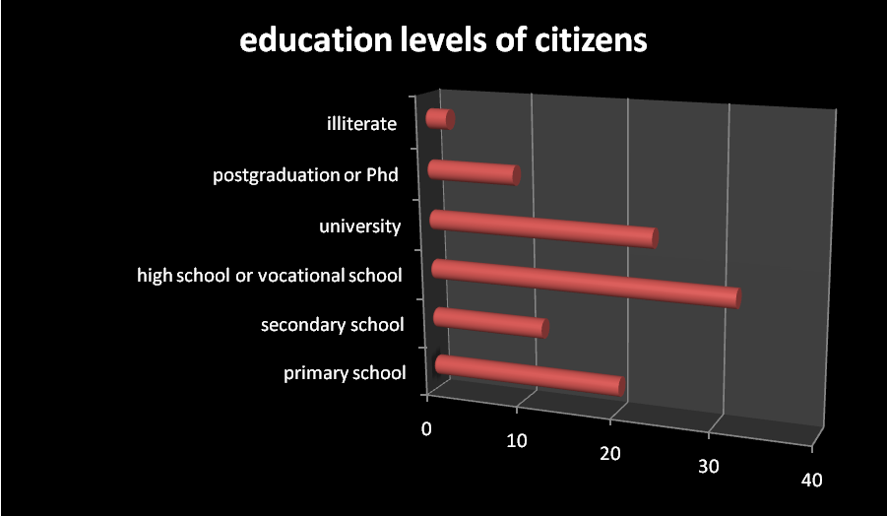
(general description and information)
typology of employment (general description and information)
 |  |  | how he moves (means of transport)
(general description and information)
with whom he moves (family, groups, in couple) - (general description and information)
(general description and information)
ways used for organizing the travel (by himself, online tools, tour operators...) - (general description and information)
 |  |  | main motivation of the travel (for work, relax, cultural attractions…)
Brief description,
Sources, related links:
Çeşme tourism information office,
Çeşme Turistik Otelciler Birliği
http://www.cestob.com/

B | Tourist offer
3 | (trend)  Accomodation facilities
3.1 | Accomodation structure
 | trend of the number of accomodation structures in last 5 years | for ex: data in last 5 years - chart
 | trend of the number of accomodation structures in last 5 years - referred to hotels | for ex: data in last 5 years - chart
 | trend of the number of accomodation structures in last 5 years - referred to other typologies of accommodation | for ex: data in last 5 years - chart
Kısaca açıklayın (gerekiyosa grafikle gösterin)

Kaynaklar / ilgili linkler

3.2 | Sleeping accomodation
 | trend of the number of sleeping accomodation in last 5 years
 | trend of the number of sleeping accomodation in last 5 years - referred to hotels | 2012  Hotels with stars 577.029 249.227 826.256 Other type of hotels 143.065 42.340 185.405  2011  Hotels with stars 606.565 411.639 1.018.204 Other type of hotels 177 .720 42.984 220.704  2010  Hotels with stars 406.002 164.315 570.317 Other kind of hotels 102 .200 39.950 142.150  2009  Hotels with stars 406.002 164.315 570.317 Other kind of hotels 102 .200 39.950 142.150
 | trend of the number of sleeping accomodation in last 5 years - referred to other typologies of accomodation | 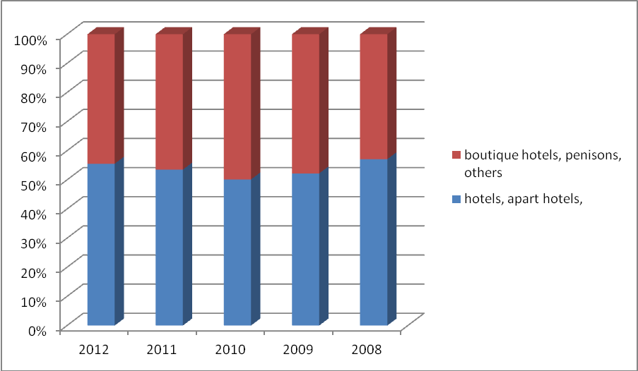
Brief description and charts:

2012 arrivals arrivals arrivals accomodation
Local foreigner total local foreigner total
Hotels with stars 197.283 43.499 240.582 577.029 249.227 826.256 Other type of hotels 75.071 4.473 79.544 143.065 42.340 185.405 Pensions, aparts, 305.896 10.763 316.659 761.525 128.165 889.690 Total 578.250 58.735 636.785 1.481.619 219.732 1.701.351
2011
Hotels with stars 231.854 107.727 339.581 606.565 411.639 1.018.204 Other type of hotels 79.608 4.500 84.108 177 .720 42.984 220.704 Pensions, aparts, 324.386 10.828 335.214 945.993 130.116 1.076.109 total 635.848 123.055 758.903 1.730.278 584.739 2.315.017

2010
Hotels with stars 246.168 48.116 294.284 501.378 216.688 718.066 Other kind of hotels 66.340 3.750 70.090 148 .100 35.820 183.920 Pensions, aparts, 270.322 9.024 279.346 788.328 108.430 896.758 Total 582.830 60.890 643.720 1.437.806 360.938 1.798.744
2009
Hotels with stars 186.681 52.215 238.896 406.002 164.315 570.317 Other kind of hotels 46.180 4.900 51.080 102 .200 39.950 142.150 Pensions, aparts 182.500 10.100 192.600 540.270 111.870 652.140 total 415.361 67.215 482.576 1.048.472 316.135 1.364.607
2008
Hotels with stars 192.773 35.034 227807 467.480 149.364 616.844 Other kind of hotels 38.580 4.101 42.681 85.200 32.927 118.127 Pensions, aparts 152.222 9.703 161.925 457.100 94.690 551.790 Total 383.575 48.838 432.413 1.009.780 276.981 1.286.761

Hotels with stars 577.029 249.227 826.256 Other type of hotels 143.065 42.340 185.405

Hotels with stars 606.565 411.639 1.018.204 Other type of hotels 177 .720 42.984 220.704
Hotels with stars 406.002 164.315 570.317 Other kind of hotels 102 .200 39.950 142.150 ,
Hotels with stars 406.002 164.315 570.317 Other kind of hotels 102 .200 39.950 142.150

Brief description,
Sources, related links:
Çeşme tourism information office,
Çeşme Turistik Otelciler Birliği
http://www.cestob.com/

4 | Accommodation facilities - Current picture
4.1 | Accomodation structures
 | number of accomodation structures in 2011 | Structures rooms beds  total 429 7386 17238
 | number of accomodation structures in 2011 | Structures rooms beds  Pensions 94 925 2065  Hotels 131 3611 8236  Villa and aparts 43 1073 3152  Boutique hotels 160 1777 3785
 | number of accomodation other typologies of structures | Camping 2 26 78
Brief description,
Sources, related links:
Çeşme tourism information office,
Çeşme Turistik Otelciler Birliği
http://www.cestob.com/

4.2 | Sleeping accomodation
 | number of sleeping accomodation in 2011 | 1.701.351
 | number of hotels accomodation in 2011 | 334
 | number of sleeping accomodation in other typologies of structures | 95
Brief description,
Sources, related links:
Çeşme tourism information office,
Çeşme Turistik Otelciler Birliği
http://www.cestob.com/

5 | Turizm  Services and infrastructures
5.1 | means of transport, iletişim ağları (turist kartları gibi)…  Description (and data) of the presence of transport infrastructures, tourist information points, trekking and cycling paths, restaurants, means of transport, networks (like tourist cards)… | Means of Transport:  The town has a six-lane highway connecting it to Izmir, Istanbul and all other destinations. It is an hour drive from Izmir metropolitian city and Adnan Menderes Airport, and there are several bus companies that will drive you to Çeşme from Izmir on any time of the day.  Bus services are also available from Istanbul, the route lasts approximately 8 hours.  Ships and Ro-Ros:  There are two daily ferries to and from Çeşme from the Greek island of Chios, the boat ride takes just over an hour. There is also transportation available to the ports of Bari and Brindisi in Italy from the port of Çeşme.  Marinas:  The south coasts of peninsula are among the main routes of yachts. About 2000 yachts arrive and depart from the marinas around Çeşme. The most crowded and popular one is Çeşme marina in the center of the town with its unique suitability. It has a capacity of 750 yachts. Yachts are able to have all the services like electiricity, water, oil, internet connection, phone, repairement and stayment during the whole year.  The others are in Dalyan, Alaçatı and Altınyunus. Çeşme marinas are the favorite of sailors among the ones in Aegean and Mediterranean.  The town has a Tourism Information office and it is on the service during the whole year.  Cycling paths are constructed around Alaçatı and it will be constructed in Çeşme in the following years.  Sail and Yacht Clubs:  Çeşme Sail Exper club established in 1985 trains new sailors around Yıldızburnu every year. They aim to train the children and young people to create the sailors of the future. The club arranges many races and championships every year.  Restaurants of Çeşme and Alaçatı welcomes their guests during summer period and rest of the year and they serves select examples of local Aegean dishes, seafood, mezzes and Mediterranean cuisine all through the year.
Brief description,
Sources, related links:
Çeşme tourism information office,
Çeşme Turistik Otelciler Birliği
http://www.cestob.com/

5.2 | Links to sites for tourist promotion (where tourists can find offer) - ex. Tour operators, touristic web site, ecc.) | www.cesme.gov.tr/  www.cestob.com/  www.ceso.org.tr  http://www.cesme2chios.com/index.php/tr/  www.cesme-bld.gov.tr/  www.alacati.bel.tr  alacati-rehberi.com  alacati2020.org  http://www.bisikletlealacati.org.tr/  www.naciyeteyze.com/etiket/alacati-turizm-dernegi  http://www.cesme.net/  http://www.cesme.gen.tr/
Brief description,
Sources, related links:
Çeşme tourism information office,
Çeşme Turistik Otelciler Birliği
http://www.cestob.com/

5.3 | Cooperation (presence of clusters, networks, public- private cooperations) in tourism sector and their responsability (and links to web site) | Cooperation with neighbouring Greek Island Chios:  Considering the geographic location, the common history and culture on both sides of the Aegean Sea, high tourism potential and their peoples’ hospitality Greek Island Chios and Çeşme are two neighbor destinations that developed a successful cooperation in the field of tourism.  To improve the cooperation opportunities creation and continuation of a confidence atmosphere between two countries’ entrepreneurs played a vital role. Tourism investors will become pioneers to realize such an atmosphere. The cooperation proposals can be summarized as follows:  Cooperation on the basis of organizations  Presently, there are works on the development of tourism between two countries being implemented by public and private sector institutions, as well as by the non-governmental organizations. One of this cooperation is established between Çeşme Tradesmen Union and Chios Hoteliers Union. After the negotiations both of the organisations declared and agreement, according to that protocol Çeşme and Chios will attend in international tourism fairs together, and hotels which are the members of tradesmen and hoeteliers union in Çeşme and Chios will make a 50 percent discount for each other. And they are planning to improve their cooperation further.  Çeşme Hoteliers  Union  The Union aims:  To be up-to-date with global developments in tourism, to gather information especially about lodging accomodation services and to pass this information to the industry and to our members.  To play a pioneering role in the marketing, promotion and sales activities in the lodging industry and to conduct and implement necessary researches.  To take part in local or international stock markets, fairs and exhibits related to tourism and hotel management.  To be instrumental in informing managers and executives about recent developments in the tourism industry; to work with other organizations within the tourism and hospitality industries.  To monitor global tendencies in tourism, to gather and disseminate information about lodging services and markets and to provide assistance in related matters.  To join and recruit members for international organizations, to participate in their meetings and organize such meetings.  To join and send representatives to any future organizations and councils related to the tourism industry, to hold memberships in already existing ones and to send representatives to official bodies related to tourism.  To protect the common interests of hoteliers  To engage in activities in line with our goals in all areas related to the tourism industry and to fulfill any other functions to be defined in laws and legislations.  To cooperate with the relevant ministry regarding the planning and implementation of new investments in accordance with national and international rules and principles.  To advise the relevant ministry in matters related to tourism  The Union of Tradesmen in Çeşme  Organization of tradesmen, craftsmen, hotel and pension keepers who acts together to achieve common goals and to keep their benefits. The union aims cooperation between members, to support them in different ways:  to grant credits for its members  To take part in local or international stock markets, fairs and exhibits related to trades  To join and send representatives to any future organizations and councils related to industry, to hold memberships in already existing ones and to send representatives to official bodies related to tradesmen and craftsmen  to work with other organizations within the tourism and all kind of marketing industries.  To monitor global tendencies in marketing, to gather and disseminate information about markets and to provide assistance in related matters.  -
Brief description,
Sources, related links:
Çeşme tourism information office,
Çeşme Turistik Otelciler Birliği
http://www.cestob.com/

5.4 | Attractions, facilities, key tourist issues | Curative beaches of Ilıca and Şifne:  The most important speciality of Çeşme is that, sand, sea and thermal springs are together. It is very rare to have such a richness. The thermal water in Şifne about 42 degrees hot, very rarely seen around the world, reaches to Ilıca , and it heats up the salty water. The water comes up to the surface with minerals. Thus, the sea water on Ilıca and Şifne beaches become a big thermal pool. Many different sizes of hotels and lodgings in Ilıca offer the thermal water to their guests.  2 kilometers long Ilıca Beach:  White and silky sand of Ilıca beach makes it unique with two kilometers of warm sea. It doesn’t get deep as far out as 100 meters.  The beach of the North: Boyalık  Another favorite of tourists with its fine and white sand.  The calm sea, vivacious beach: Ayayorgi:  The bay is known as ‘the calm sea’ because of its wind proof location  Gold beach: 5 kilometers far from the county center, southwest shores of the peninsula provides visitors its most beautiful sand and virgin beaches.  Brilliant Beach: the beaches are accompanied with kitesurfing, this area also offers possibilities to those who would like to camp.  Ildırı bays and Islands:  There are about 28 small islands on the Gulf of Ildiri. Daily boat trips are organized to these small islands offer the beauty of nature to be witnessed.  Eşek Island and Mavi Islands are the favourites of daily tours  The Significiant diving points:  It is possible to see many available diving places around the Eşek island. The point called as the yarık kaya offers the best view of the underwater for the divers.  Fener Island, Yatak Island, Topuk Island and Ildiri Gulf are other beautiful diving places with serial cave stones.  Wınd Surfing in Alaçatı:  Çeşme’s Alaçatı town gains its fame because of its strong wind mainly the famous northern winds of Çeşme Peninsula. In the last twenty years a lot of surfing managements and schools started. The fame of Alaçatı spread all over the world in a very short time and this old Greek town practically rose like the Phoenix from its own ashes.  The wind blows throughout the shore creates boisterous but even waves. The calm breeze creates a safe environment for beginner surfers as well. Consequently Alaçatı is one of the three best wind surfing spots in the world and surfing trainings continue during all 12 months since its windy atmosphere for 300 days of the year.  Beach clubs  It is possible to find a beach club on every bay of Çeşme. Except beaches, night clubs, jazz and rock bars, discos and local clubs are attractions of Çeşme nights.  Arts in Çeşme  Summer night concerts, theatres, exhibitions of paintings and ceramics are daily attractions of çeşme in summer.  Seafoods:  The racing restaurants lined as a stream can be seen as if they were built to offer the fish and seafood pleasure only. The attractive restaurants of Dalyan are full of people.  Ayayorgi which is famous with night clubs is also pretentious in the area of fish restaurants.  Çiftlikköy is the main station of this delight. If you meet boats coming from fishing you see how sea gifts the fisherman.  Another fisherman village is Ildiri offers its guest the best seafoods like barbun, kefal and sea bream.  The wine which is made by Çeşme grapes in Çeşme vineyards can be the chatting friend in your dinner.  Local foods of herbs cooked with olive oil.  Kumru is another local attractive food which is a special kind of hot sandwich.  Mastic Tree which is grown in Çeşme and neighbouring Greek town Chios is the main ingredient of special delights. Gum jam with its aroma is used in ice-creams, cookies, puddings and raki.  Kopanişti cheese:  Another taste originating from common source of Çeşme and Chios island is Kopanişti cheese. It is a specific cheese made of generally goat milk but sometimes the mixture of goat and ship milk can be used in this kind of cheese. The preparation method is rather difficult as it requires kneading for 40 days. Such period provides the cheese with necessary fermentation and the taste .  Alaçatı bazaar and other local bazaars are other attractions of the town  Unique villages’ of Çeşme: daily life in the villages takes you to atmosphere of thousands of years ago.  Sakız sheep: this kind of sheep which is known also as the Çeşme’s sheep is able to giving birth to 5-7 baby at only one generation. The milk productivity of Sakız sheep reaches to 200 liters per year.  description of main tourist products; typologies; elements with tourist appeal
Brief description,
Sources, related links:
Çeşme tourism information office,
Çeşme Turistik Otelciler Birliği
http://www.cestob.com/

5.5 | Other services | Museum, Library, Tourism Information Centre, General Directorate of Public Accounts, Directorate of Land Registry and Cadastrate, Port Authority, General Directorate of Social Assistance, Trade corporation, Chamber of Agriculture, Union of Hoteliers, Municipality of Çeşme Hospitals, Health care services, Police Departments, Gendarmerie, Cost Guard, Municipality of Çeşme, Municipality of Alaçatı  description of other non-directly tourism-related services (social services, security, social and political situation)

C | Tourism Local Policies and strategies
6 | Institutional referents for tourist sector
6.1 | Local referents for tourist policies | İZKA- Izmir Development Agency  İŞKUR-National Employment Office,  KOSGEB –Small and Medium Enterprises Development Organisation,  ÇEŞTOB - Union of Hoteliers in Çeşme,  Association of Tourism in Alaçatı,  ÇESO - Union of Tradesmen,  District Government of Çeşme,  Municipalities of Alaçatı and Çeşme,  University of Ege,  Vocational High schools of Tourism in Çeşme, are local referents to be considered by would-be entrepreneur in tourism
6.2 | Tourism development strategies for next years | Tourism Strategy for Turkey – 2023  Coastal tourism is currently the most popular type of tourism in Turkey. In addition to coastal tourism, Turkey has several unique opportunities for different types of tourism such as health and thermal resources, winter sports, mountain climbing, conference and expo tourism, cruise ships and yachting, golfing, etc. However, a good deal of this potential is not yet utilised. In order to establish a framework for utilising these alternatives,  the Ministry of Culture & Tourism has issued Turkey’s 2023 Tourism Strategy with the intention of guiding the tourism industry in production management and implementation phases, by creating a roadmap for the sector.  With this framework, those investors who are considering investing in the sector will be supported by the government in terms of planning, land allocation, and with respect to tourism projects. The characteristics and shapes of such incentives will be determined on an annual basis.  Health & Thermal Tourism  The following four regions of Turkey are suitable for health and thermal tourism:  • South Aegean region: Aydın, Denizli, Manisa, and İzmir;  Sea Tourism  A single authority will be responsible for all entry procedures for foreign flagged yachts. All income generated  from the operation of yacht tourism will be invested back into infrastructure development for the sector. Fairs will be funded and the development of yacht club  Turizmin geleceği için Ana stratejiler ve belgeler / araçlar ve bu belge ve araçların geliştirildiği kurumlar (yıllık veya uzun vadeli stratejiler)  main strategies and main documents/tools where these strategies are developed (like yearly or multi-years plans and so on)  Sea Tourism  A single authority will be responsible for all entry procedures for foreign flagged yachts. All income generated  from the operation of yacht tourism will be invested back into infrastructure development for the sector. Fairs  will be funded and the development of yacht clubs will be encouraged. Legislation will be rearranged so that  sail-powered yachts will pay less tax than engine powered yachts. Technical standards will be developed for  the processing of bilge water and solid waste disposal. Steps will be implemented to organise the training of  workers for the yacht tourism sector.  Congress and Expo Tourism  The Ministry of Culture and Tourism will organise meetings to shape the required framework for congress and expo tourism for seven priority cities: Istanbul, Ankara, Antalya, İzmir, Bursa, Konya and Mersin.
http://www.kulturturizm.gov.tr/genel/text/eng/TST2023.pdf

7 | Tourist laws/regulations
7.1 | Main laws/regulation in tourist sector
http://www.kulturturizm.gov.tr/genel/text/eng/TST2023.pdf
http://www.luxembourgforbusiness.lu/market-entry-guide-turkey#chap-office-foreign-entity

7.2 | Law/ administrative requirements for Tourists
Brief description, resources and links
The Ministry of Tourism and Culture
http://www.kulturturizm.gov.tr/genel/text/eng/TST2023.pdf

7.3 | Main local financial opportunities for tourist sector | Government Incentives  There are various investment incentives offered within the Law of for the Encouragement of Tourism (Law no: 2634). Below is a summary of these incentives:  • Land Allocation for Tourism Investment: Public land can be allocated to tourism facilities up to 49  years with relatively economic prices.  • Employment of Foreign Staff: Certified tourism establishments may employ qualified foreign personnel  and experts with the approval of the Ministry of Tourism and the Ministry of Interior. Provisions of the  Law concerning the Trades and Services to be performed in Turkey by Turkish Citizens are not  applicable to such personnel. However the total number of foreign personnel employed may not be  higher than 10% of the total number of employees. This ratio may be increased up to 20% by the  Ministry of Tourism. Such foreign staff may start working at the establishment 3 months prior to the  commencement of commercial operations.  The employment of personnel aged fewer than 21 at certified tourism establishments and covered by  Law no 2559 concerning the Duties and Powers of the Police shall be subject to the prior permission  of the highest civil authority of the local area.  • Communication Facilities: All procedures and allocations in connection with requests of certified  tourism investments and establishments for telephone and telex facilities are carried out on a priority  basis.  • Favourable Treatment as Exporters: Of the certified tourism establishments, those earning foreign  exchange in the amounts that are specified annually by the Ministry for this purpose are considered as  exporters.  • Tourism Loan: The Tourism Bank Inc. of the Republic of Turkey may obtain foreign currency loans  from foreign sources for allocation to certified investments in tourism areas and tourism centres
Brief descriptions, resources, related links
http://www.kultur.gov.tr/EN,33040/law-for-the-encouragement-of-tourism.html

8 | Diğer
8.1 | Country reputation | Look at National Ministries data and the website of the Country Brand Index: www.futurebrand.com
Brief descriptions, resources, related links
http://www.kultur.gov.tr/EN,33040/law-for-the-encouragement-of-tourism.html

8.2 | Foreseen projects related to tourist sector (opening of a new museum, building of new infrastructures…) | Megayacht Marines are fast growing trend of recent years in Çeşme sea tourism. In an effort to conveniently address this demand plans have been made for constructing a new marine in Paşalimanı – Şifne. The new marine is planned and will be designed, built and opened up for operation with capacities sufficient to support visitor arrivals.  Thermal cure centre is another project planned in Alaçatı. From the early periods of time, people wishing to make use of the treatments offered by nature aim to return to their health by visiting thermal springs. Today the number of people taking part in thermal tourism movements increase rapidly mainly in developed countries and the ageing populations participate in thermal tourism for third age and health tourism purposes.  Although the thermal springs in Çeşme (Turkey is among the first seven countries in terms of the spring richness) have superior characteristics than the other thermal springs in Europe with its porperties of volume of flow, hotness, and physical and chemical ingredients, the number of tourists visiting Turkey is still less than the countries in Europe. The same position is valid for Cesme which can‟t get its share from the overall tourism industry movements, although it has great tourism potential with its unique beaches, surfing and swimming, climate and thermal springs and a good network of transportation, etc.  At this point, the aim of the project is to develop improvement tendencies evaluating the current thermal springs to obtain a bigger share from the overall tourism movements for the benefit of Cesme and spread the tourism season into 12 months.
Brief descriptions, resources, related links

8.3 | Tripadvisor opinions about the area | http://www.tripadvisor.co.uk/ShowForum-g298004-i2696-Cesme_Izmir_Province_Turkish_Aegean_Coast.html  http://www.tripadvisor.com.tr/Attractions-g298004-Activities-Cesme_Izmir_Province_Turkish_Aegean_Coast.html  http://www.tripadvisor.com.tr/AllLocations-g298004-c2-Attractions-Cesme_Izmir_Province_Turkish_Aegean_Coast.html  Tüm Çeşme turizm bölgesiyle ilgili Tripadvisor’da varsa bir link ve yer alan görüşler  Link to Tripadvisor page with opinions about the whole territory as tourist destination (if existing)

D | Innovation
9.1 | Internet and wi-fi coverage (data and/or general description) | Connecting to the Internet in Çeşme and Alaçatı hotels is pretty easy and inexpensive.  If you travel with your own laptop or tablet computer (iPad, etc.), most hotels, particularly the small and medium-sized ones—offer fast (ADSL) wireless Internet access (Wifi) in at least one public space, such as the lobby or lounge.  More and more hotels have repeaters that convey the signal to all the guest rooms as well.  Most hotels, inns, pensions and hostels have a computer dedicated to the Web and email for guests' use, or the owner will allow you to use an office computer.  Wifi access is usually free in smaller hotels and inns.  Cafés and some restaurants around the town are also setting up Wifi access for their customers. Adnan Menderes airport have Wifi (though it is not free)  You may have to ask your hotel staff for the password to access their system.  Virtually all luxury hotels have Wifi, as well asEthernet ports (RJ-45) for high-speed connections in their guest rooms.  Some intercity bus companies offer Wifi on selected routes and bus types, though reliability varies.
9.2 | Cool hunting (identification of new trends in Tourist sector) | http://en.wikipedia.org/wiki/Coolhunting
9.3 | Identification of Best Practices of innovative services and companies with the application of new web 2.0 technologies to tourist sector | Most of the Çeşme and Alaçatı hotels are defined in various international networks like bookingcom and tripadvisor. And most of them have their own websites.  Also some local networks are in service to help tourists who intends to visit Çeşme. Some of them are :  alacati-rehberi.com  alacati2020.org  http://www.bisikletlealacati.org.tr/  www.cestob.com/  www.ceso.org.tr/  www.naciyeteyze.com/etiket/alacati-turizm-dernegi  http://www.cesme.net/  http://www.cesme.gen.tr/
9.4 | National opinion leaders | www.cestob.com/  www.ceso.org.tr  http://www.cesme2chios.com/index.php/tr/  Link to forum, blog, people, companies who can be considered as opinion leaders about this issue

E | Sürdürülebilirlik
10.1 | (hotels, crafts, products) of sustainable services and practises in tourist sector (Enviromental-Friendly Businesses) | - 100% organic cotton sheets, towels and mattresses  - Non-smoking tourist accomodations  - Renewable energy sources like solar or wind energy  - Bulk organic soap and amenities instead of individual packages to reduce waste  - Guest room and hotel lobby recycling bins  - Towel and sheet re-use (guests can tell housekeeping to leave these slightly used items to reduce water consumption)  - Energy-efficient lighting  - Serve organic and local-grown food  - Non-disposable dishes  - fresh-air exchange system  Sözkonusu sürdürülebilir çevre dostu iyi uygulamalara ait linkler  Links to identified best practices
10.2 | Local policies about sustainability | Local Policies about sustainability  As well known, environment protection is one of the crucial points for sustainable tourism. Tourism and environment are inseparable components, also for the Çeşme Tourism.  Local authorities works on various infrastructures like renewing the drainage system, enriching the fresh water supplies, developing the recycling system. According to act of town council all the new built houses have to plant traditional gum trees into their green areas. Wind plants are built up for the energy demand of the town. And the centreal government and local authorities encourages these kind of enterprises. Problems on the Aegean Sea need to be examined in two parts  Coast and Sea Water Protection: It is important to create an environment consciousness among local population, tourism staff and tourists. For this purpose we have to improve Blue Flag campaigns in both Çeşme. Furthermore, public and local authorities should educate population on the environment protection. In this context, measures should be augmented against yachts and other boats which cause coast dirtiness. We can create common projects on quality destination in some selected tourism centers. Culture fishery near tourism centers is another factor causing water pollution. Public authorities also need to be warned to take necessary measures.  - Protection of cultural heritage  For mutual protection of cultural heritage lobbying activities should be strengthen. We should not forget that wise usage is the best protection.  A pilot project on environment protection and recycling can be developed and various funds can be used for this project.
Related links and resource

10.3 | Enviromental-Friendly Mobility examples | Some of the hotels in and around Çeşme has made important environmental improvements like: use of renewable energy sources, an overall reduction in energy and water consumption, measures to reduce waste, environmental policy setting and the provision of non-smoking areas. But none of these hotels have been certified green by an independent third-party or by the state. Lots of the hotels are environmental friendly because of their location and their design inspired by the use of traditional building methods applied by skilled local craftsmen .  Green hotels follow strict green guidelines to ensure that their guests are staying in a safe, non-toxic and energy-efficient accommodation. Here are some basic characteristics of a green hotel:  - Housekeeping uses non-toxic cleaning agents and laundry detergent  - 100% organic cotton sheets, towels and mattresses  - Non-smoking environment  - Renewable energy sources like solar or wind energy  - Bulk organic soap and amenities instead of individual packages to reduce waste  - Guest room and hotel lobby recycling bins  - Towel and sheet re-use (guests can tell housekeeping to leave these slightly used items to reduce water consumption)  - Energy-efficient lighting  - On-site transportation with green vehicles  - Serve organic and local-grown food  - Non-disposable dishes  - Offers a fresh-air exchange system  - Graywater recycling, which is the reuse of kitchen, bath and laundry water for garden and landscaping  - Newspaper recycling program  The term has been used on a more regular basis as new websites devoted to the subject become more prominent and hotel owners become more interested in protecting the areas their guests have come to visit.  New properties are being built from sustainable resources–tropical hardwoods, local stone–and designed to better blend in with their environment. In addition, they are also being run on eco-friendly principles, such as serving organic or locally grown food or using natural cooling as opposed to air conditioning.
Brief descriptions, resources, related links

 | National opinion leaders | The Union of Hoteliers in Çeşme has started a campaign with the tittle : tell about your idea for Çeşme. It aims to encourage all the citizens and lovers of Çeşme to think about the Çeşme and create ideas fot its development. The campaign attracts lots of opinion owners to tell about their ideas. The web site created by the action comitte will receive ideas until the end of May and the results will be announced by the jury. There are many topics for new ideas and the visitors choose the related topic to declare their ideas. The best ideas will have awards like the round the world tour, the travel of Europe, etc.  and Fikir önderi diye nitelendirilebilecek kişi, kurum, blog ve şirketler varsa bunlara ait bağlantılar  Link to forum, blog, people, companies who can be considered as opinion leaders about this issue
Brief descriptions, resources, related links

http://cesmeicinfikrimvar.com/Fikir_kumbarasi.php

F | Best practise in tourist sector | Her ortak kuruluş kendi bölgesinde öne çıkmış yenilikçi ve sürdürülebilir girişimcilik örneklerini tarayıp tespit eder, ve ikinci toplantıda başarılı bir girişimcilik örneği olarak sunulmak üzere hazırlar  each partner tries to identify an example of innovative or sustainable new business in tourist sector in his area, to be involved in second meeting as a best practise.  Identification of best practises is not obligatory, if partners don't have or can’t find them on their territory

